Part One: In the sentences provided below, please take three steps
- Complete the labeling table.
- Create a sentence diagram.
For these first set of problems, I have identified the sentence pattern for you. You can refer to the chart on p. 24 and look at the chapter for additional info and examples. You can also use the example trees in my Sentence Patterns Handout to help you.
In some of my tree diagrams and tables, I ask students to identify the “roles” in the sentence such as direct object (DO), adverbial (Advl), Subject Complement (Subj Comp), etc. There is no need to identify any roles for this homework assignment.
Different books number these patterns differently, so it is better to use the terminology rather than numbers. Rather than use the number, we will use words to describe the sentence pattern using one of these options:
- Copular "Be" (pattern 1 or 2. on p. 24)
  - In our class, we will combine both 1 & 2 into one group.
- Linking Verb with a Subject Complement (pattern 3 on p. 24)
- Intransitive (pattern 4 on p. 24)
- Transitive (pattern 5 on p. 24)
- Ditransitive with a Direct Object (pattern 6 on p. 24)
- Ditransitive with an Object Complement (pattern 7 on p. 24)
- The students are very tired.

Sentence Pattern: Copular Be (Adjective Phrase as a Subject Complement)

ROLE | Subject |  | Predicate | Subject Complement
Phrase | NP |  | VP | ADJP
Word | The | Students | Are | Very | Tired
Part of Speech | Det | N | V | Adv | Adj

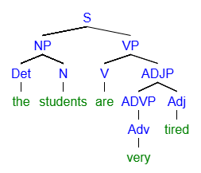
- My uncle was in jail.

Sentence Pattern: Copular Be (Prepositional Phrase as a Subject Complement)

Phrase | NP |  | VP | PP
Word | My | uncle | was | in | jail
Part of Speech | Det | N | V | Prep | N

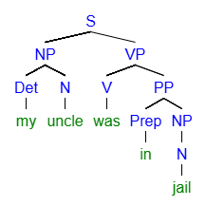
- The new teachers are experts in their field.

Sentence Pattern: Copular “Be” (Noun Phrase as a Subject Complement)
Phrase | NP |  |  | VP | NP
Word | the | new | teachers | are | experts | in | their | field
Part of Speech | Det | Adj | N | V | N | Prep | Det | N

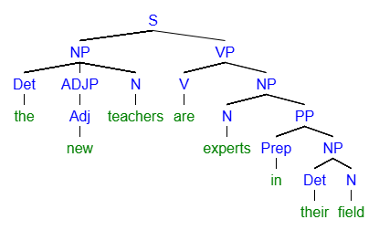
- This crime smells fishy.

Sentence Pattern: Linking Verb with an Adjective Phrase as a Subject Complement
Phrase | NP |  | VP | ADJP
Word | This | crime | smells | fishy
Part of Speech | Det | N | V | Adj
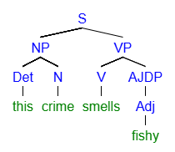
- Timothy became a bitter person.

Linking Verb with an Noun Phrase as a Subject Complement

Phrase | NP | VP | NP
Word | Timothy | became | a | bitter | person
Part of Speech | N | V | Det | Adj | N

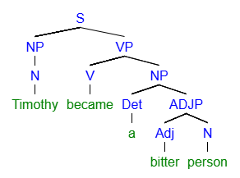
- Some players hit every shot.

Transitive (has a Direct Object)
Phrase | NP |  | VP | NP
Word | Some | players | hit | every | shot
Part of Speech | Det | N | V | Det | N
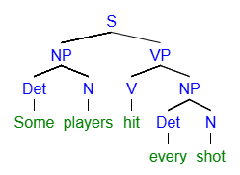

- That book contains the best ideas.

Transitive (has a Direct Object)
Phrase | NP |  | VP | NP
Word | That | book | contains | the | best | ideas
Part of Speech | Det | N | V | Det | Adj | N

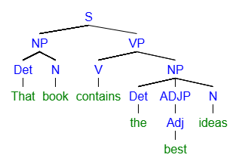

Part Two
For each of the sentences below, identify the sentence pattern. If the sentence contains any of the following roles, list and identify them.
- Subject Complements
- Direct Objects

Example:
With such high stakes, no diplomats were at Camp David
- Sentence Pattern: Copular Be
  - “At Camp David” – Subject Complement
  - “With such high stakes” – Optional Adverbial

2.1: The negotiations were secret.
- Sentence Pattern: Copular Be
  - Secret –Subject Complement (ADJP)

2.2: A successful conclusion to the 1978 negotiations appeared unlikely.
- Sentence Pattern: Linking Verb
  - “unlikely” –Subject Complement (ADJP)

2.3 Early Lincoln pennies are very valuable today.
- Sentence Pattern: Copular Be
  - “very valuable” –Subject Complement (ADJP)

2.4: In 1943 zinc-coated steel replaced the copper in the production of pennies.
- Sentence Pattern: Transitive
  - “the copper” – Direct Object

2.5: Even after 100 years, the production of the Lincoln penny continues today.
- Sentence Pattern: Intransitive

2.6: For sailors scurvy was a serious problem.
- Sentence Pattern: Copular Be
  - “A serious problem” –Subject Complement (NP)

2.7: Interestingly, Lind’s discovery affected the English language.
- Sentence Pattern: Transitive
  - “the English Language” – Direct Object

